OTCS Distributed Agent and Admin Server Report

Execution Summary
Step | Action | Result
1 | Navigate to Login Page | Navigated to http://otcsvm.otxlab.net:8080/OTCS/cs.exe
2 | Fill Login Credentials | Username and password filled.
3 | Click Login Button | Login successful, redirected to home page.
4 | Navigate to Distributed Agent Dashboard | Navigated to http://otcsvm.otxlab.net:8080/OTCS/cs.exe?func=distributedagent.AgentStatus
5 | Read Distributed Agent Status Table | Extracted 1 agents. All running: True
6 | Verify Agent Status | All agents are already running. Configuration skipped.
7 | Navigate to Admin Servers | Navigated to http://otcsvm.otxlab.net:8080/OTCS/cs.exe?func=ll&objtype=148&objaction=browse
8 | Open Function Menu for 'AdminServer-01' | Opened action menu for AdminServer-01.

Distributed Agent Status Table
Distributed Agent ID | Status
DAAgent_otcsvm_2099_1 | Running

Distributed Agent Status Verification
All agents running: Yes
Action taken: All agents were running. No configuration needed.

Step Screenshots

Step 1: Navigate to Login Page
Result: Navigated to http://otcsvm.otxlab.net:8080/OTCS/cs.exe
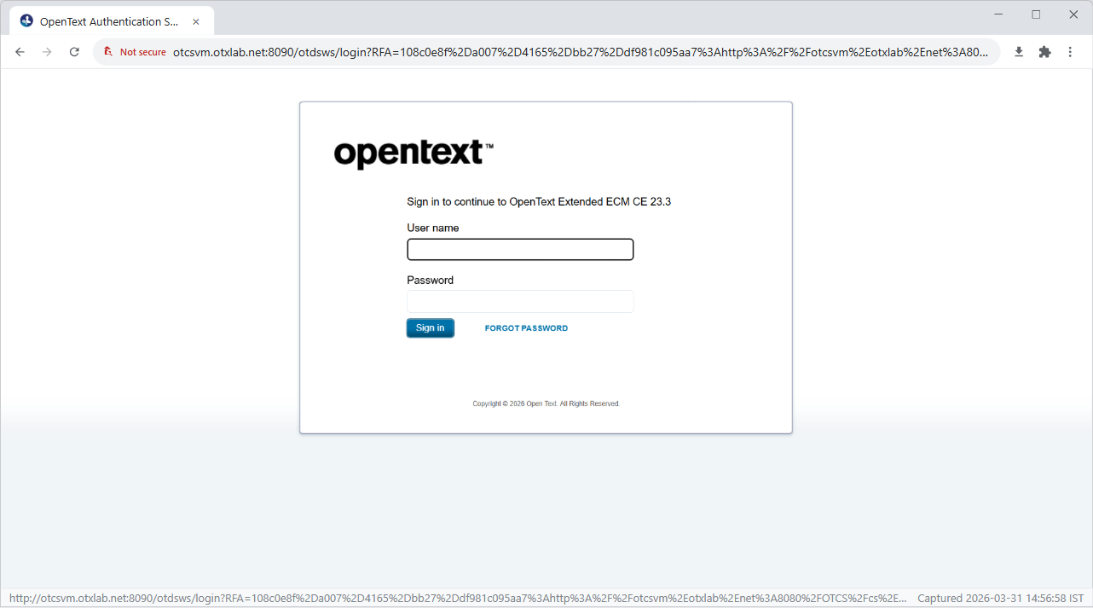

Step 2: Fill Login Credentials
Result: Username and password filled.
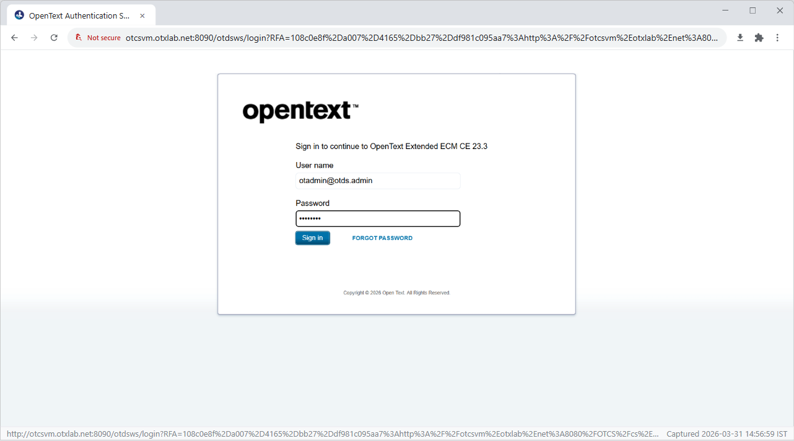

Step 3: Click Login Button
Result: Login successful, redirected to home page.
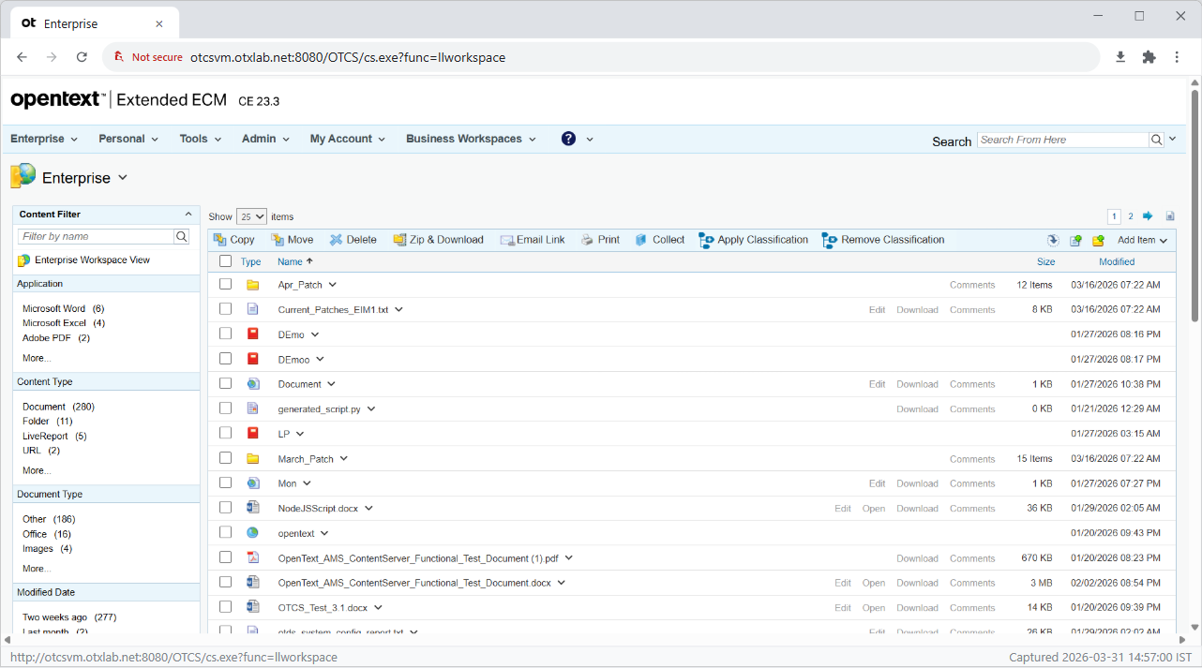

Step 4: Navigate to Distributed Agent Dashboard
Result: Navigated to http://otcsvm.otxlab.net:8080/OTCS/cs.exe?func=distributedagent.AgentStatus
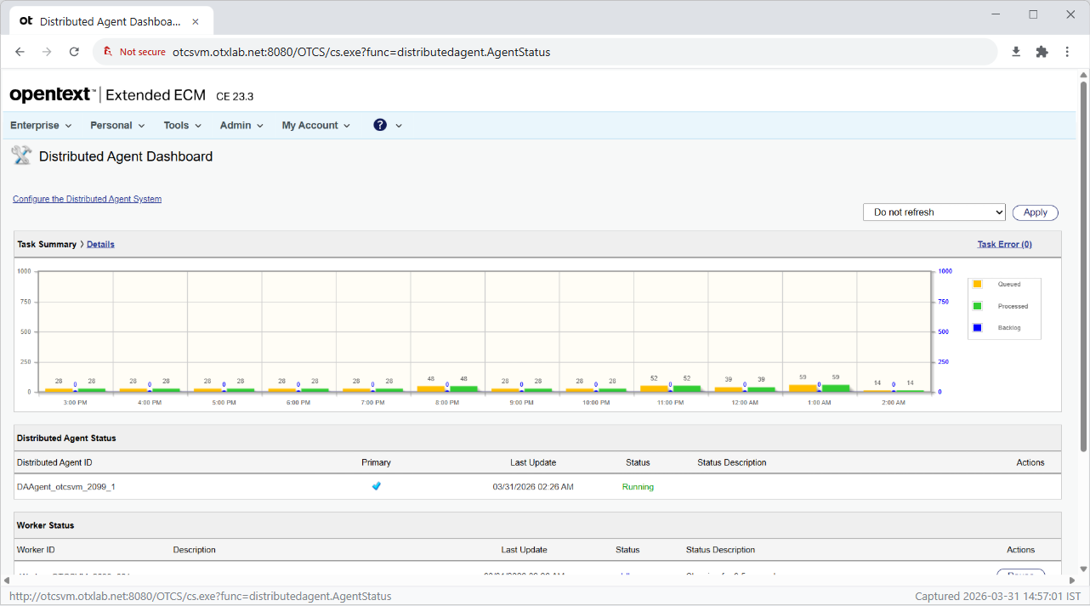

Step 5: Read Distributed Agent Status Table
Result: Extracted 1 agents. All running: True


Step 6: Verify Agent Status
Result: All agents are already running. Configuration skipped.
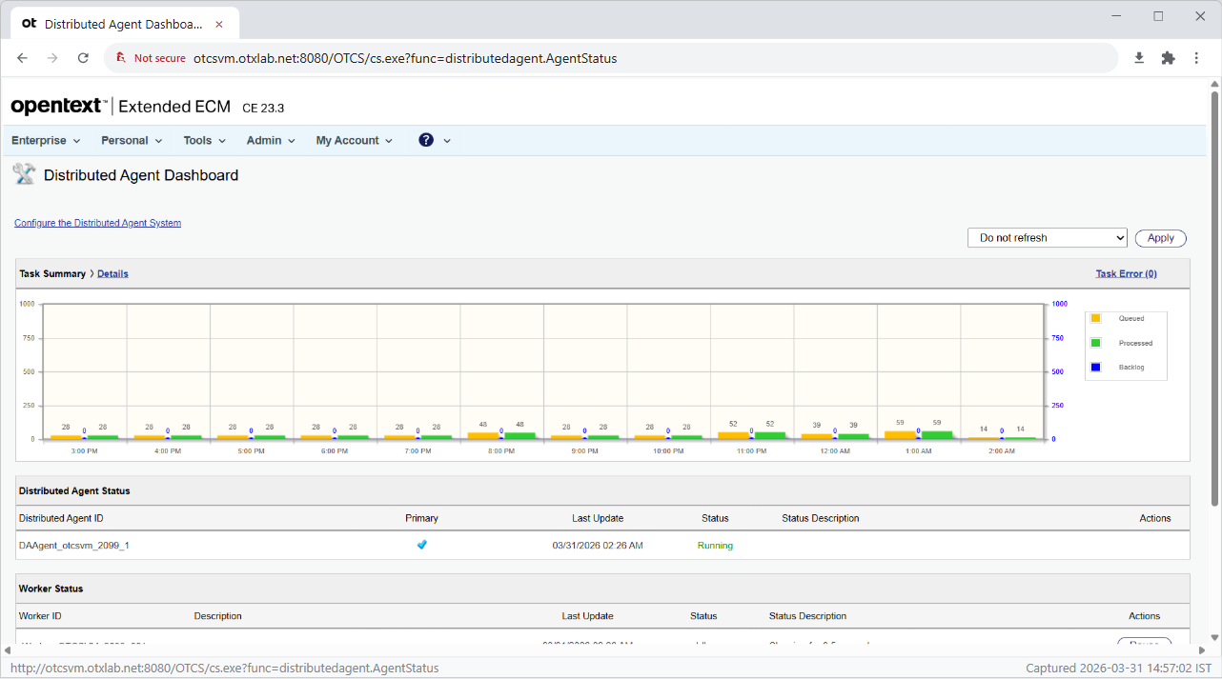

Step 7: Navigate to Admin Servers
Result: Navigated to http://otcsvm.otxlab.net:8080/OTCS/cs.exe?func=ll&objtype=148&objaction=browse
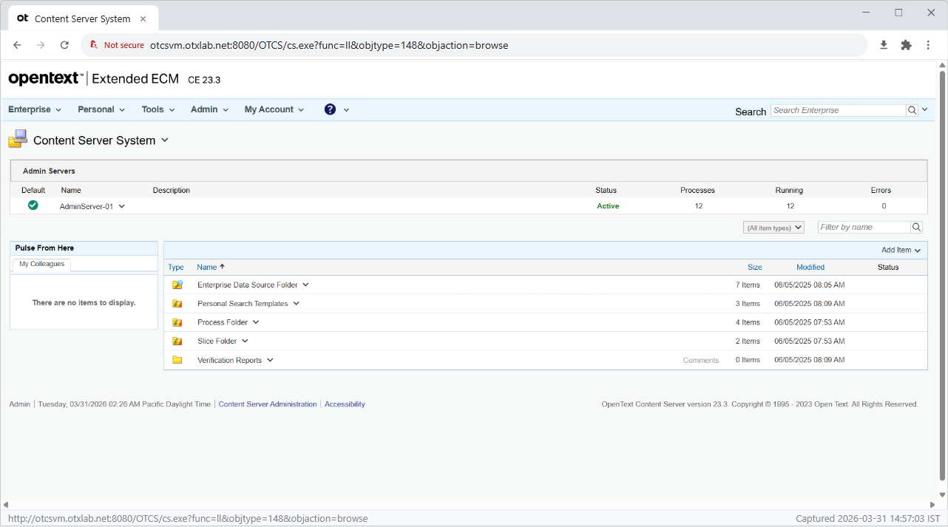

Step 8: Open Function Menu for 'AdminServer-01'
Result: Opened action menu for AdminServer-01.
